Background Study for Measuring Polarity of Harmonic and Valley Coil Contributions to the ORIC Main Field Profile

J. Ball July 2004

Background:
The studies of the ORIC field shapes produced by the Terry Cleary codes revealed that the input of positive currents for the offsets of the harmonic coils produced a field contribution that subtracted from the field produced by the main coil. Common lore for ORIC says that these coil contributions add to the main field. The question is thus raised as to what are the actual polarity of the fields that are produced by the present power supply connections to the harmonic coils. An unambiguous answer to this question would be best provided by a physical measurement of the coil effects on the field. This study was done to provide the information needed to plan for these measurements.

Preliminary Studies:
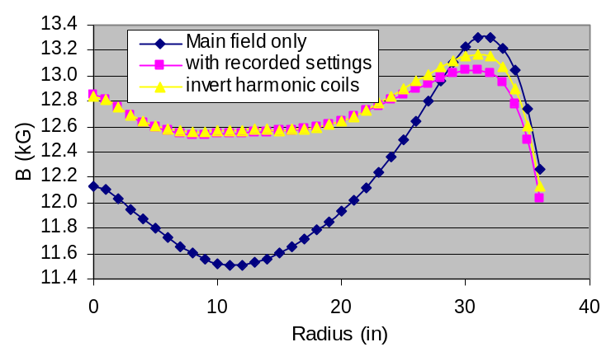
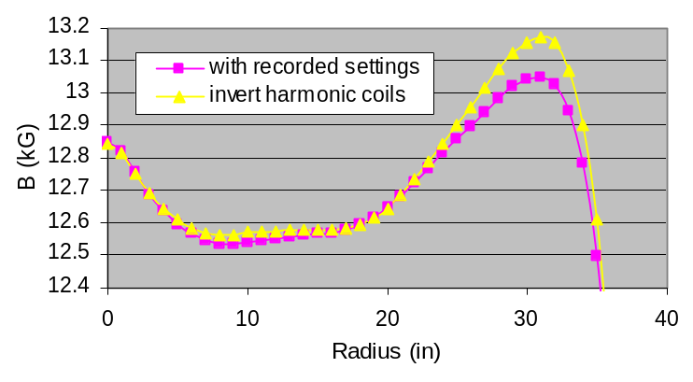
One question is certainly whether or not the offset currents in the harmonic coils produce a significant effect on the total field. To study this, the magnet coil settings recorded for the runs of 6/18/03 were used as follows: First, to provide a base field for comparison, the average field profile was computed with the main field current only. Next, the average field profile as computed with the recorded settings for all coils. Then, this calculation was repeated reversing the polarity of the offsets for the harmonic (and valley) coil sets. The results are shown at the right. The top figure shows the results from all three calculations. The bottom figure uses a slightly expanded vertical scale with only the two calculations that differ by polarity of the harmonic coil currents. As seen from these results, the polarity of the harmonic coil currents produces almost a 1% difference in average field at 31 inches. This is certainly significant in terms of calculating an isochronous field profile and is the motivation for making a physical measurement.

Measurement Studies:
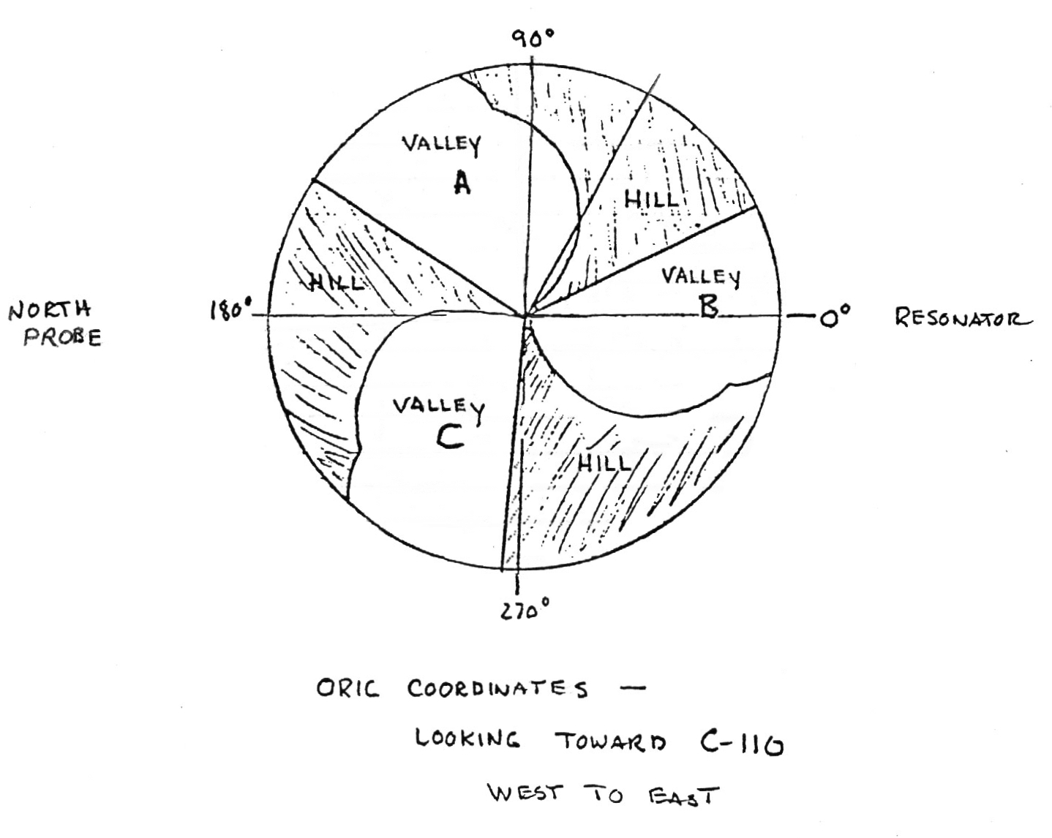
The physical layout of the valleys containing the harmonic coils is shown in the sketch at the right. The easiest valley to measure in would seem to be the “B” valley that is essentially on a straight-line extension of the north probe. However, because of the “puller” attachment on the Dee, this would not be practical with the Dee in place. With the Dee removed is would likely be much easier to measure in this valley from the resonator side. To answer the question of how accurately a magnetic probe would need to be placed in the valley, a small section of the field in this valley was calculated by computing the field for the main coil only at 1500 amps, and then repeating with the addition of harmonic coil 4 (valley) offset set to -400 amps. The difference in these two computations yields the contribution of the valley coil. This same comparison was also done for harmonic coil 3. Plots of these results are shown below.
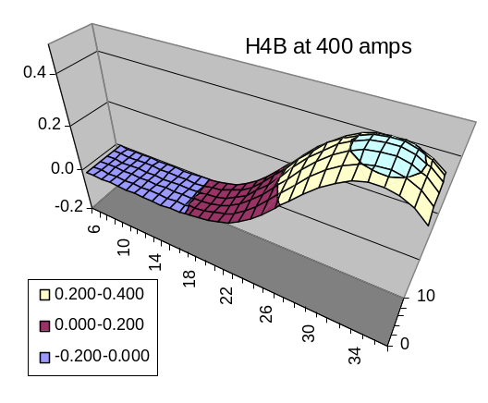
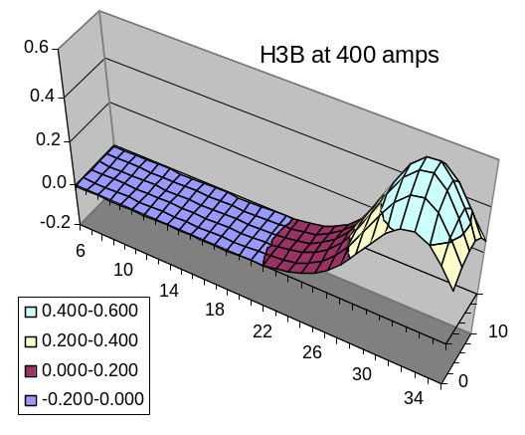

Here the plots cover radii from 6 to 36 inches and angles from 0 to 10 degrees. Remember that the calculation is for a negative current which produces a “positive” field, i.e., one that is added to the main field. This was done simply because it is easier to visualize a peak than a depression. Note that the peak field of the smaller harmonic-3 coil is slightly higher than the harmonic-4 field, but is concentrated in a significantly smaller region.
To stay above a contour that represents about 25% of the peak effect, it would appear that the position accuracy required of the probe is to be between 25 and 36 inches in radius and about ± 10 degrees (± 5.5 inches at a radius of 32 inches). Thus, we don’t have to be terribly precise in positioning a field probe in order to see the effect of the harmonic coil.
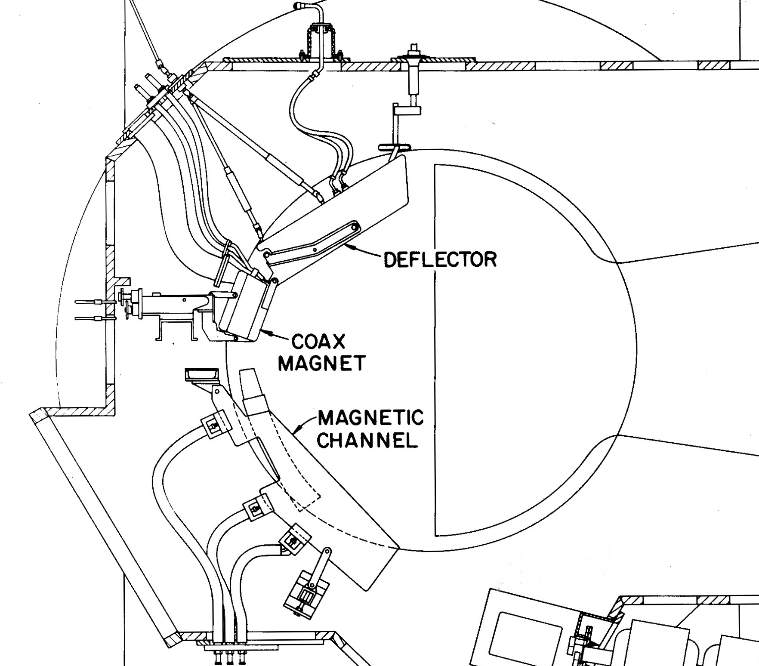
If the measurement if made with the Dee in place, then it must be done in either the “A” or “C” valleys. Here the question will be, in accessing the pole region from the vacuum manifold, which of these will be easier to access around the extraction elements. The layout of these is shown in the drawing at the right. The physical position of some of the relevant components in ORIC are given in the table below.
If the deflector is removed, then the easiest access would seem to be Valley A. If the lower channel is removed, or if nothing is removed, then the easiest access would seem to be Valley C.
Thus, the final choice of measurement location will depend on the reason for opening the ORIC tank. Obviously, the most difficult choice to plan for is the case where neither the Dee nor any of the extraction elements are removed.
For position reference, a dimensioned sketch of the ORIC pole face showing location of harmonic coils and extraction elements is included on the next page.

ORIC Component Locations

Component | Radius | "Old" Azimuth | "New" Azimuth | "New" Azimuth  Valley B | "New" Azimuth  Valley C
Harmonic Coil A1 | 12 in. | 22° | 85° | 325° | 205°
Harmonic Coil A2 | 22 in. | 39° | 102° | 342° | 222°
Harmonic Coil A3 | 32.5 in. | 63° | 126° | 6° | 246°
Valley Coil A4 | 32.5 in. | 64° | 127° | 7° | 247°
Deflector Entrance | ~31 in. | 32° | 95° | - - - | - - -
Deflector Exit | ~32 in. | 88° | 151° | - - - | - - -
Straight edge of Pole Top C | - - - | 84° | 127° | - - - | - - -

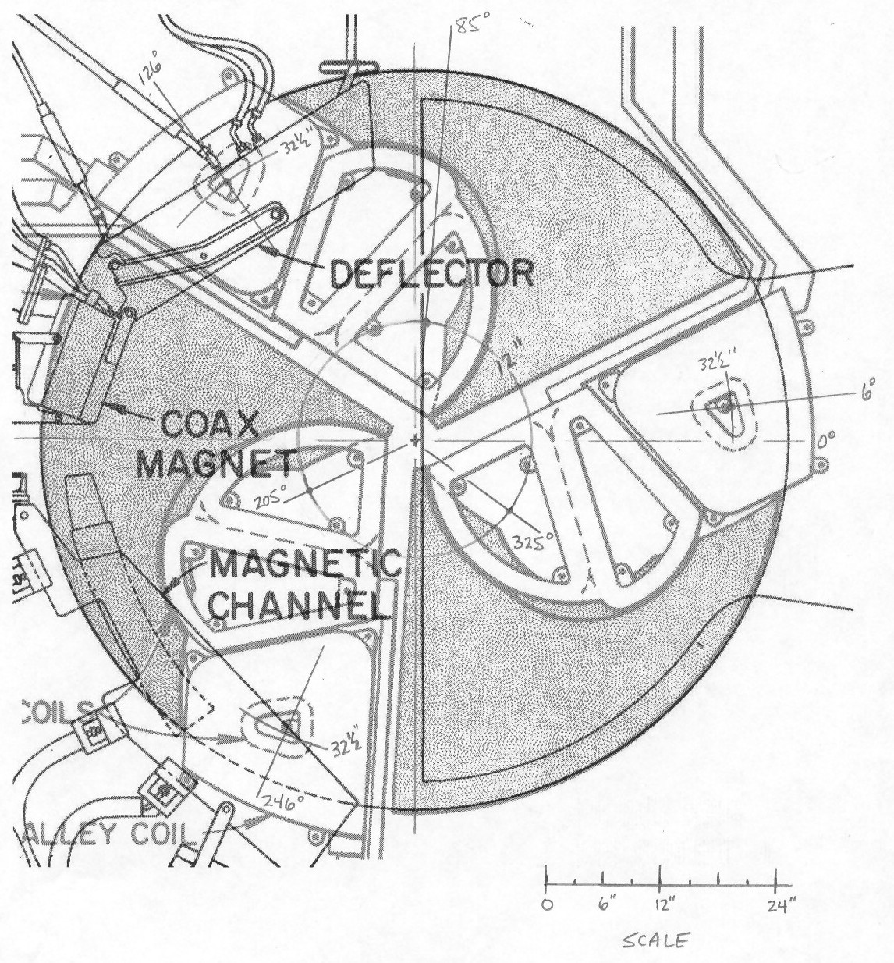
Sketch 1. ORIC pole face showing location dimensions of the three harmonic coil sets, the valley coil set (harmonic 4), and the position of the extraction elements.

